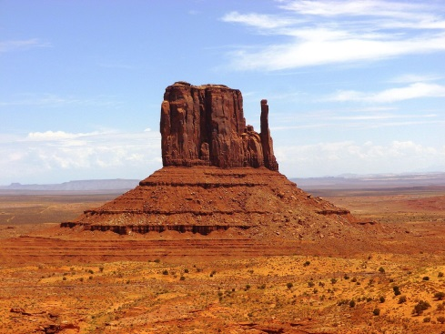
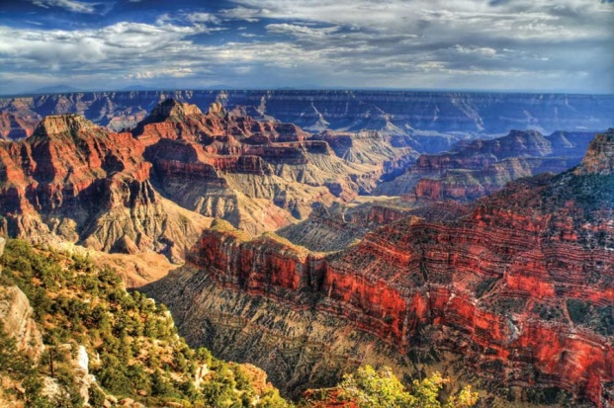

My school, Tucson Country Day School, is sponsoring a trip to the Grand Canyon and Monument Valley in February, 2019, and I would LOVE to go! We will explore these natural wonders on an exciting THREE DAY adventure!
I am asking for your support through the Arizona Tax Credit. Here’s how it works—for both of us:
- You make a Tax Credit Donation to Tucson Country Day School, listing me as the recipient for the DC Trip. You can contribute up to $200 if you file Single or Head of Household, and up to $400 if you file Married. Any amount you could contribute would help me, AND…..
- You get your money back when you file your Arizona taxes!! TCDS will send you everything you need to claim the amount you contribute on your Arizona State Taxes. (You actually get more back than you contribute, because you can also claim it on your Federal return as a Donation!)
It’s an easy, simple way to support extra-curricular education programs,
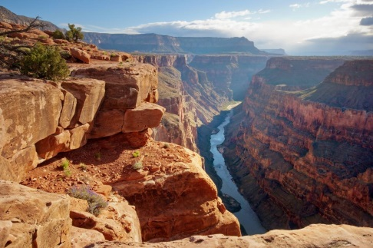
I would really appreciate it!

