Kepler’s Laws of Planetary Motion:
- The Law of Elipses: Each planet moves in an ellipse with the Sun at one focus.
  - Apsis: an extreme point in the orbit of an object.
  - Perihelion: the point in the orbit of a planet, asteroid, or comet at which it is closest to the Sun.
  - Aphelion: the point in the orbit of a planet, asteroid, or comet at which it is furthest from the Sun.
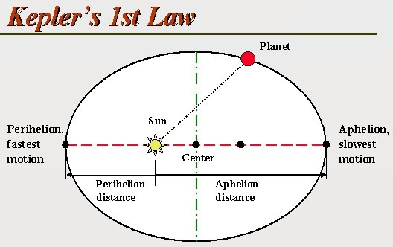
- The Law of Equal Areas: The line connecting a planet and the Sun sweeps out equal areas in equal times.

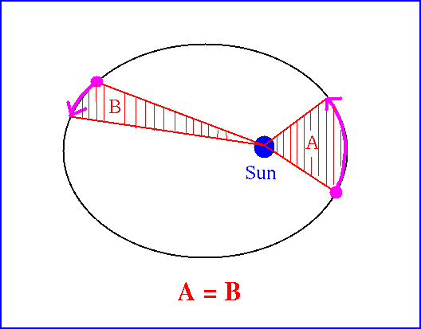
  - This gives us our months. Looking at the sheet you just put in your notebooks, you can see how the months are distributed for Earth.
  - A planet must move rapidly when it is close to the Sun and more slowly when it is far from the Sun.
- The Law of Harmonies: The square of a planet’s orbital period is proportional to the cube of its average distance from the Sun.
  - P²_{yr} = M³_{AU;} Where P is the period (the time for one cycle); and M is the length of the major axis. This equation works for all planets.
