U2A1: Kepler’s Laws
Key question: How are the months of Earth measured around the Sun?
Johannes Kepler (1571-1630)-Using detailed measurements of the path of planets kept by Tycho Brahe, Johannes Kepler determined that planets traveled around the sun not in circles, but in ellipses.
Law of Ellipses: All planets move about the Sun in elliptical orbits, having the Sun as one of the foci. Also, rather than the orbits laying on a linear plane, the orbits of the planets are angled.
As the planet revolves in its orbit around the sun, the planet sweeps out in equal areas over equal time; hence giving our months.
Law of Equal Areas: A radius vector joining any planet to the Sun sweeps out equal areas in equal lengths of time. As seen in the image below, although closer to the Sun, the Northern Hemisphere is experiencing winter because of the 23.5⁰ tilt of Earth’s axis. Conversely, the Southern Hemisphere is experiencing summer as well.
Seasons N. Hemisphere S. Hemisphere
Winter Solstice Dec, Jan, Feb Jun, Jul, Aug
Vernal Equinox Mar, Apr, May Sept, Oct, Nov
Summer Solstice Jun, Jul, Aug Dec, Jan, Feb
Autumnal Equinox Sept, Oct, Nov Mar, Apr, May
Remember root words: equi=equal; nox=night/dark; Equinox=equal night. Solstice=either of the two times in the year when the sun reaches its highest or lowest point in the sky at noon, marked by the longest (summer) and shortest (winter) days.

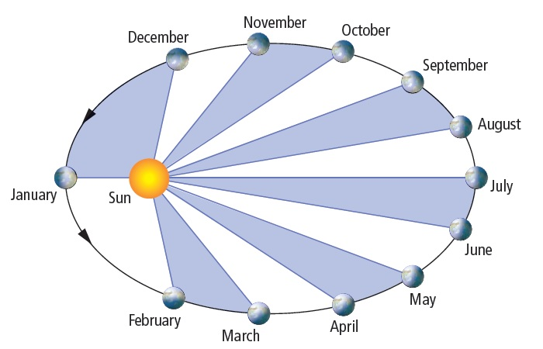

Law of Periods: The squares of the sidearal periods (of revolution) of the planets are directly proportional to the cubes of their mean distances from the Sun

